WEEK 3 – REAL-WORLD MINI PROJECT
DESIGN AND ASSEMBLY OF A MACHINE VICE
Using PTC Creo Parametric

Student Name | Harish S.
Department | B.E. Mechanical Engineering
College | Government College of Engineering, Bodinayakanur
Internship | Mechanical CAD Internship
Project | Machine Vice – 3D Part Modelling and Assembly

1. Introduction
The Week 3 Real-World Mini Project was completed as part of the Mechanical CAD internship. The selected project is the design and assembly of a machine vice using PTC Creo Parametric. A machine vice is a mechanical work-holding device used to hold a workpiece securely during machining and other workshop operations. The project was developed as a three-dimensional CAD assembly to apply the part-modelling and assembly skills learned during the previous internship tasks.
2. Objective
The main objective of this project is to plan and build a small end-to-end mechanical CAD project. The work includes creating individual components, applying suitable modelling features, assembling the components using assembly constraints, and preparing documentation of the completed design. The project also provides practical experience in component identification, dimensional planning, 3D modelling, assembly, and technical presentation.
3. Software Used
- PTC Creo Parametric – Part modelling and assembly
- Microsoft Word – Project report preparation
4. Main Components Modelled
Component | Function
Base | Supports the complete vice assembly and provides the mounting structure.
Fixed Jaw | Provides the stationary clamping surface.
Movable Jaw | Moves relative to the fixed jaw to accommodate a workpiece.
Jaw Grip / Jaw Plate | Provides the contact surface for holding the workpiece.
Screw Rod / Spindle | Represents the screw mechanism used to adjust the movable jaw.
Handle | Provides a lever for operating the screw mechanism.
Nut, Washer and Other Fasteners | Support the assembly and represent common fastening elements.
5. Part Modelling Procedure
- Created the individual machine vice components as separate Creo part files.
- Prepared sketches on suitable reference planes and defined the required geometry and dimensions.
- Used solid modelling features such as Extrude, Cut, Hole, Revolve and Fillet where required.
- Created the base, jaws, screw-related components, handle, grip plates and supporting fasteners.
- Checked the individual parts and saved the required Creo part files before starting the assembly.
6. Assembly Procedure
- Created a new Creo assembly and inserted the base as the main reference component.
- Inserted the fixed jaw and positioned it on the base using suitable assembly constraints.
- Inserted the movable jaw and aligned it with the base and fixed jaw.
- Added the screw rod/spindle and positioned it along the required axis.
- Added the handle, jaw grips, nut, washer and other components shown in the final assembly.
- Checked the overall arrangement and confirmed that the components were correctly positioned.
- Saved the completed machine vice assembly.
7. Completed Machine Vice Assembly
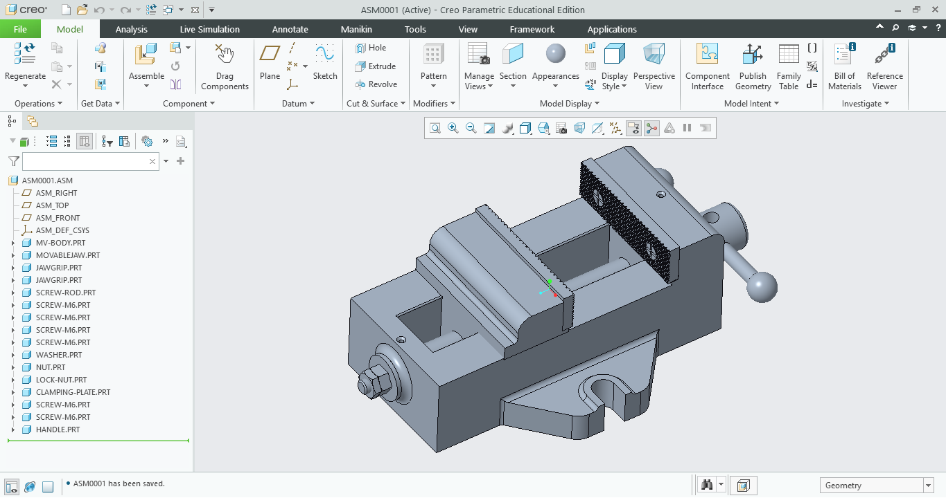
Figure 1: Completed Machine Vice Assembly in PTC Creo Parametric
8. Applications
A machine vice is commonly used as a work-holding device in machine shops. It can be used to hold workpieces during operations such as drilling, milling, filing and other machining processes. The CAD model created in this project represents the construction and arrangement of a machine vice for educational and design-learning purposes.
9. Skills Learned
- Improved understanding of mechanical component design.
- Practised 3D part modelling in PTC Creo Parametric.
- Learned to organize multiple components into an assembly.
- Improved understanding of assembly constraints and component positioning.
- Developed skills in technical documentation and CAD project presentation.
- Gained experience in planning and completing an end-to-end mechanical CAD mini project.
10. Conclusion
The machine vice project successfully demonstrates the application of mechanical CAD concepts in a real-world type of mechanical assembly. The project involved planning the design, modelling individual components, assembling them in PTC Creo Parametric, and documenting the final result. This activity helped strengthen practical knowledge of part modelling, assembly techniques, component functions and engineering visualization. The completed CAD assembly provides a useful foundation for future mechanical design projects and more detailed machine-component modelling.

